2-Setup your github

1. Download GitHub Desktop from <https://desktop.github.com>

* 1. Leave it… for now…

1. Go to GitHub.com and create an account with your RPI email

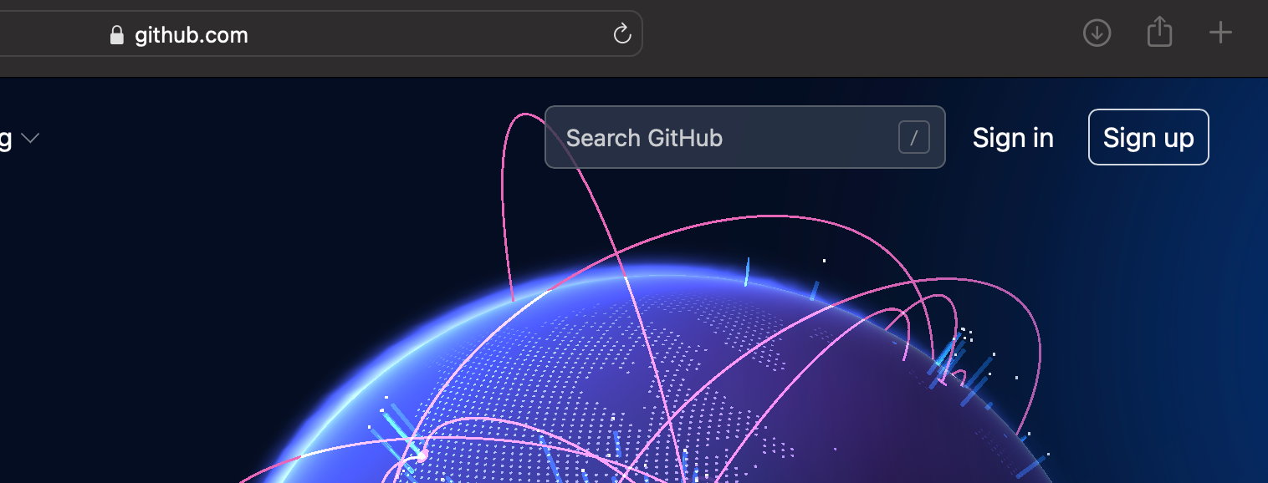

* 1. If you already have an account on GitHub, go to your profile and add your rpi email

1. Send your GitHub id, RPI email address to [mojiso@rpi.edu](mailto:mojiso@rpi.edu) and to me [rplotka@rpi.edu](mailto:rplotka@rpi.edu)
   1. We will add you to the ITWS1100 Team on GitHub
2. Take a screenshot of your profile page

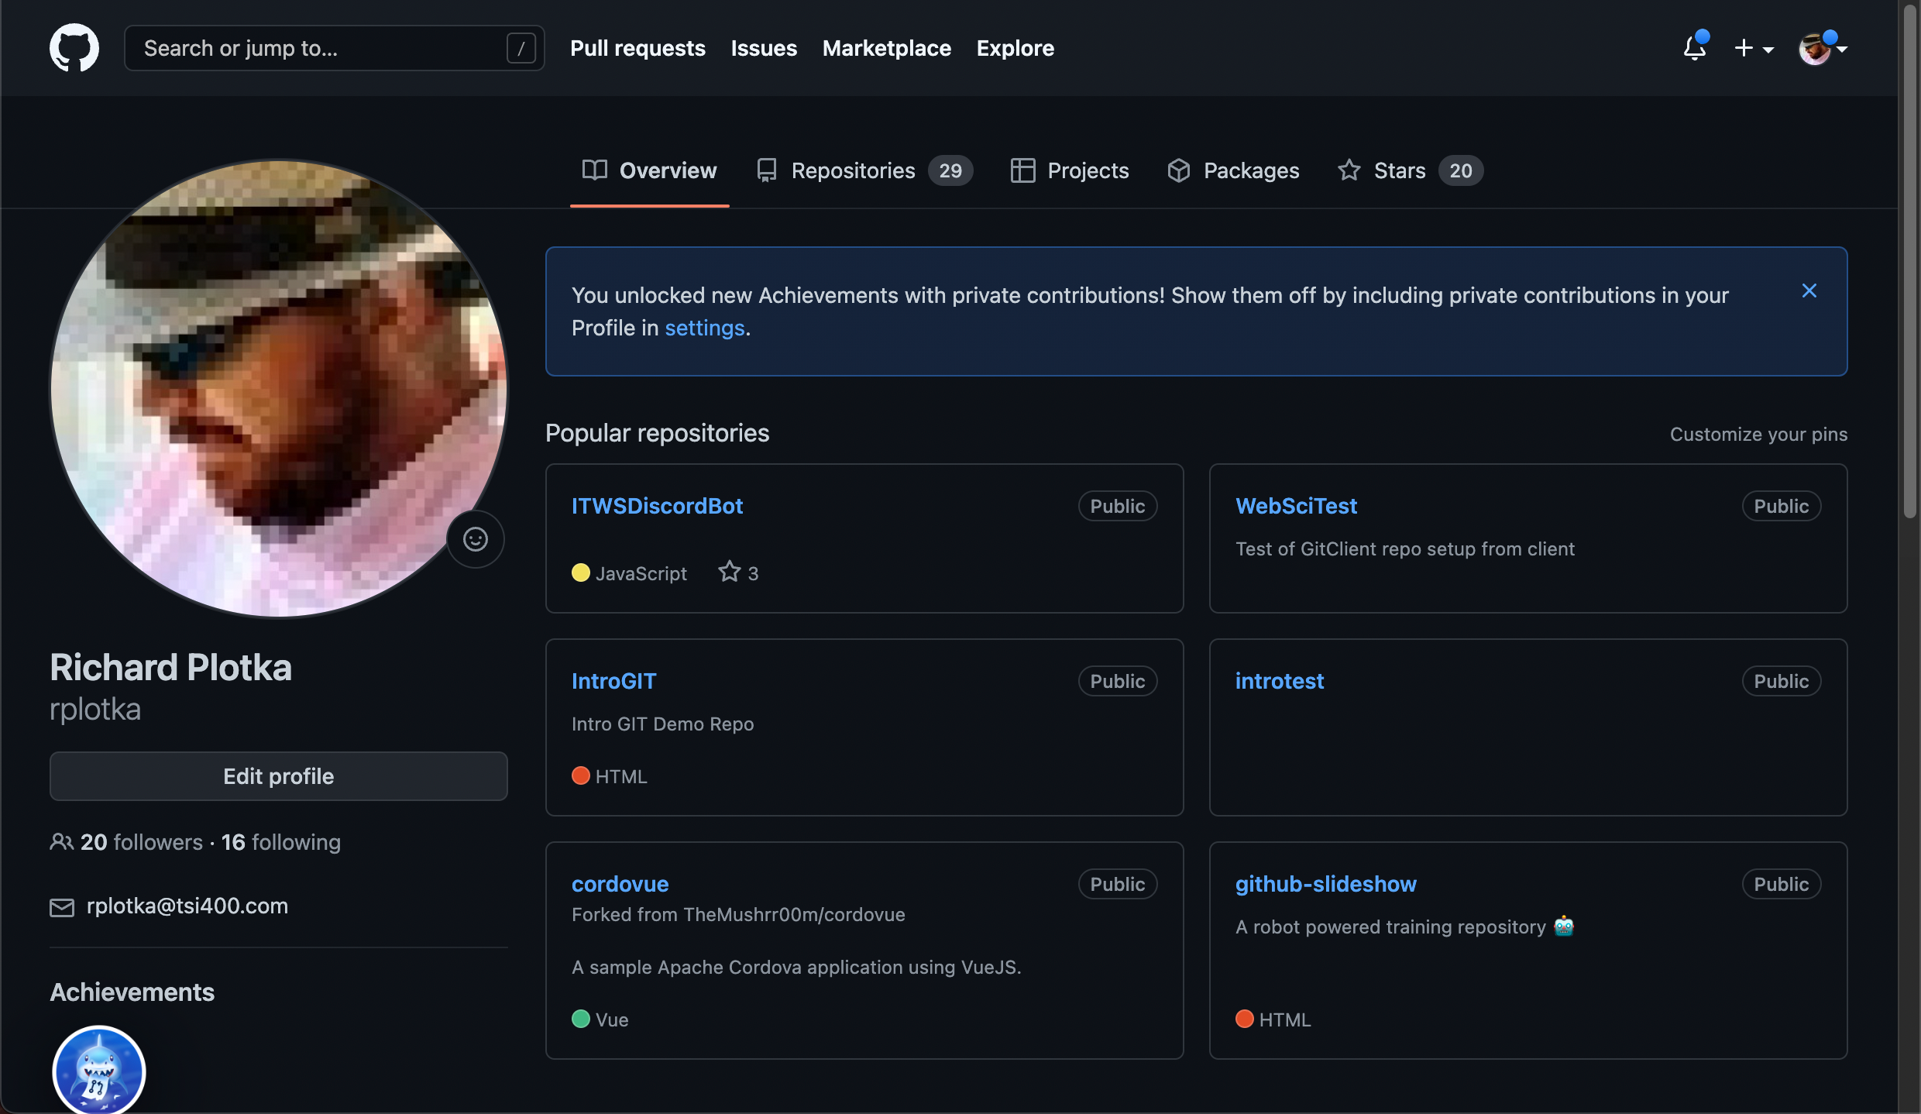

1. That’s it for now